

# A PROJECT REPORT

## ON

## PLACEMENT PORTAL

**By**

Prashant Kumar

Reshma Afreen

Shahana Anjum

Shreeyesh Chauhan

**Guided by**

Ms. Bhagyashree Alhat

##### DEPARTMENT OF COMPUTER ENGINEERING

MIT ACADEMY OF ENGINEERING

ALANDI (D), PUNE

2017 - 2018

###### CERTIFICATE

This is to certify that the seminar entitled “PLACEMENT PORTAL” has been carried out by PRASHANT KUMAR, RESHMA AFREEN, SHAHANA ANJUM, SHREEYESH CHAUHAN under guidance of MS.BHAGYASHREE ALHAT in partial fulfillment of Third Year Computer Engineering of Savitribai Phule Pune University, Pune during the academic year 2017-2018.

Ms. Bhagyashree Alhat Dr. Shitalkumar. A. Jain

**Seminar Guide**   **Head of the Department**

###### ACKNOWLEDGEMENT

It gives me immense pleasure and sense of satisfaction to present this report on “PLACEMENT PORTAL” and expressing sincere and deep appreciation towards my guide Prof. BHAGYASHREE ALHAT for priceless execution of steering this contribution all the way through this work with soft suggestion ,embedded supervision and invariable advocacy .

I am thankful to Head of Department Prof. Dr Shital Kumar . A. Jain for his valuable guidance and encouragement and good cooperation. I thank everybody who directly or indirectly helping to make my project successful and submitting this report within time.

**ABSTRACT**

The project name is Placement Portal a Company information system is web based

System. The placement portal is Developed attempt to take a record of company by restricting such a large database to that of particular class of company. The system provides the facility of viewing academy information of companies. The Student Company are also provided with the facility of editing some field like user name and password. The project also allow the database administrator to enter the information of student and company which is then stored in the corresponding tables in the main database. He can also delete the student and company information after placement over from main database.

**INDEX**

1. INTRODUCTION

* 1. . Introduction to project
  2. . Problem Statement
  3. . Purpose of the project
  4. . Project Objective

2. IMPLEMENTATION DETAILS

2.1. Hardware requirement

2.2. Software requirements

3. SYETEM DEVELOPMENT

3.1. SDLC Model

3.2. DFD Diagrams

3.3.Use Case Diagram

3.4. Screenshots

3.5. Coding

4. FUTURE SCOPE

5. CONCLUSION

6. REFEREANCES

1. **INTRODUCTION**
   1. **Introduction to project:**

Placement management system is a student/company information system which is a window based **application created in HTML And CSS**. The project has been developed on the basis of “Placement Portal” being presently used in the University for storing and retrieving the information of students and companies who are registered in placement Portal.

The Placement Portal was developed as an attempt to take a record of company and students by restricting such a large database to that of a particular class of students or company. The System provides the facility of viewing both the personal and academic information of the student and company it can also search for eligible students and company and also insertion and deletion of records by the administrator. The GUI used for the project provide instruction and the various actions performed on button clicks or on selection of items, guide the user through a series of pages as in the project.

**1.2.Problem Statement:**

Now a day, Student joins the college for better education as well as for better placement for their future. So the placement activity takes important role. In existing system all the transactions are done manually. Fake entries can be there system is more error- prone & time consuming. Difficulty in managing data of students. Large files of records are to be maintained. Placement Officer has to collect the information of various companies who want to recruit students and notify students time to time about them. It is a time consuming activity of managing, updating and informing specific student for specific company requirements.

**1.3. Purpose of the project:**

placement portal is Developed attempt to take a record of company by restricting

Such a large database to that of particular class of company. The system provides the facility of viewing academy information of companies.

**1.4. Project Objective:**

In order to avoid above existing placement problem we are planning to design a system for online Placement, so that Placement activities becomes more interactive, automated and effective.

1. Reduce the paper work and create data base of student.

2. Save time & work load .

3. Easy to access.

4. Avoid fake Entry.

5. User friendly interface.

**2.IMPLEMENTATION DETAILS**

**2.1. HARDWARE REQUIREMENTS:**

Content Description

HDD 20GB Mini

40GB Recommended

RAM 1GB Mini

2GB Recommended

**2.2. SOFTWARE REQUIREMENTS:**

Content Description

Operating System Windows7, Windows 10,

Linux, macOS

Technologies HTML , CSS

Database My Sql

**3. SYSTEM DEVELOPMENT**

**3.1.SDLC Model:**

The basic popular models used by many software development firms are follows:   
A) System Development Life Cycle (SDLC) Model

B) Waterfall Model

C) Rapid Application Development Model

D) Prototyping Model

1. **System Development Life Cycle Model (SDLC Model):**

This is also called as Classic Life Cycle Model (or) Linear Sequential Model (or) Waterfall Method.

This model has the following activities.   
1. System/Information Engineering and Modeling   
2. Software Requirements Analysis   
3.Systems Analysis and Design   
4.Code Generation   
5. Testing

6.Maintainace

**3.2. ER Diagrams:**

A Entity Reletionship diagram is graphical tool used to describe and analyze movement of data through a system. These are the central tool and the basis from which the other components are developed the transformation of data from input to output, through processed, may be described logically and independently of the physical components associated with the system. These are known as the logical data flow diagrams. A full description of a system actually consists of a set of Entity Reletionship diagrams.

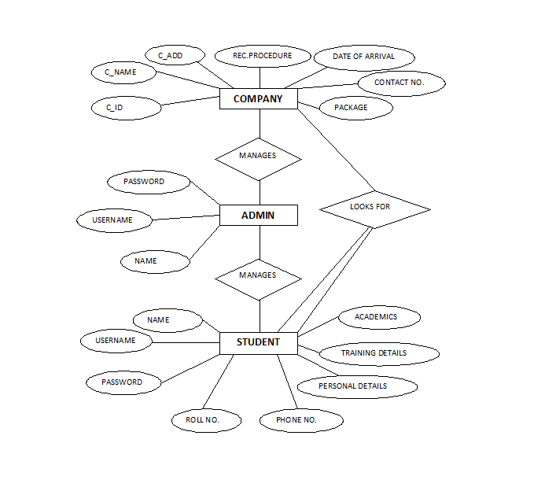

**3.3. Use Case Diagram:**

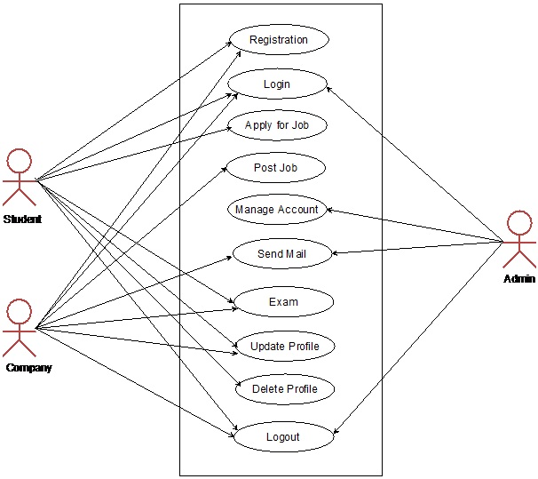

**3.3. Screenshot:**

Signup: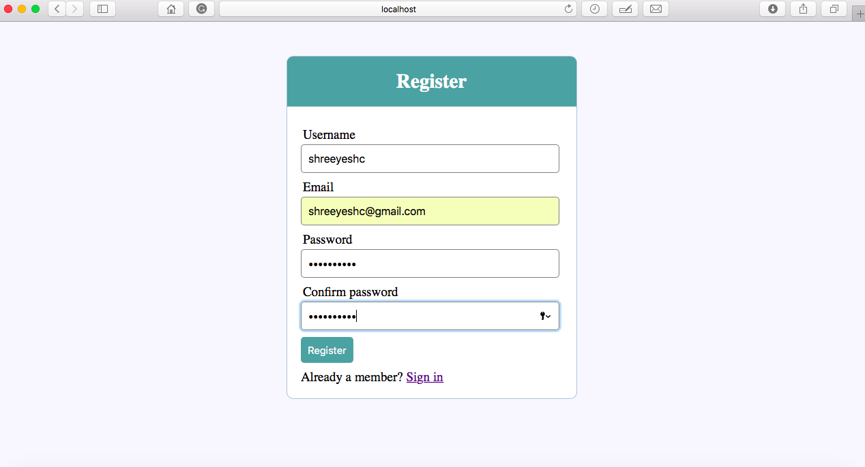

Signin-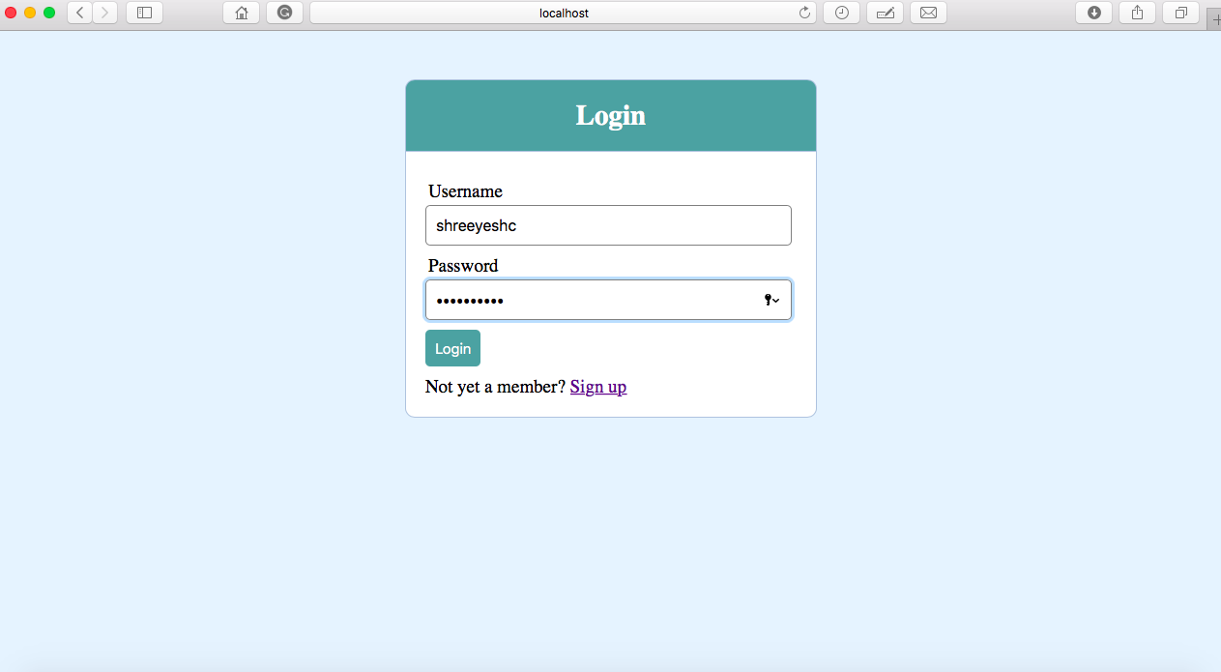

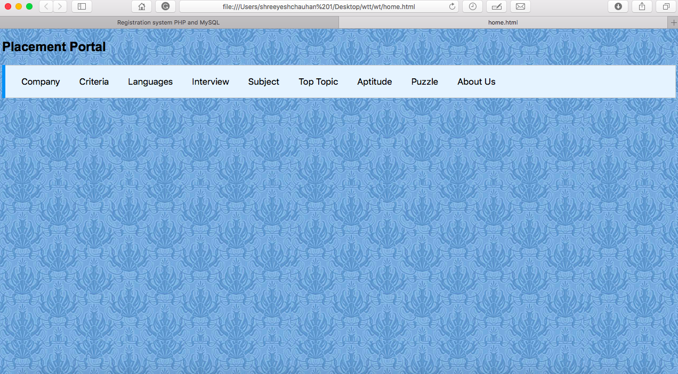

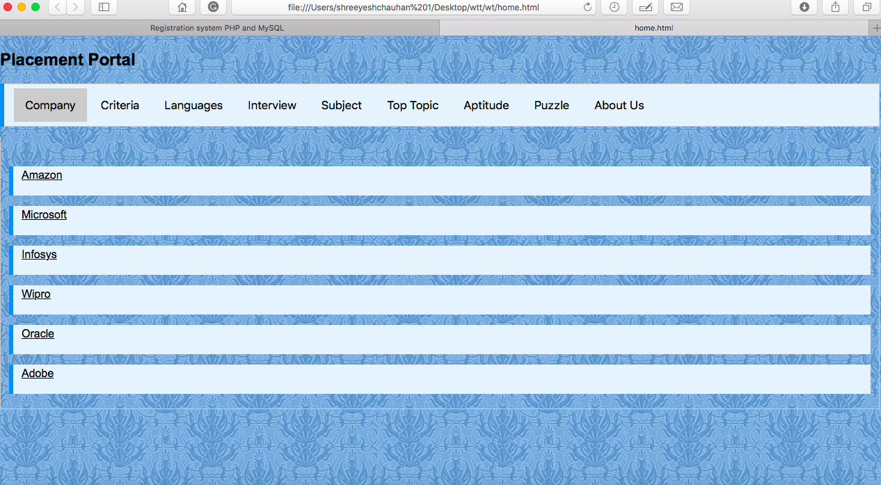

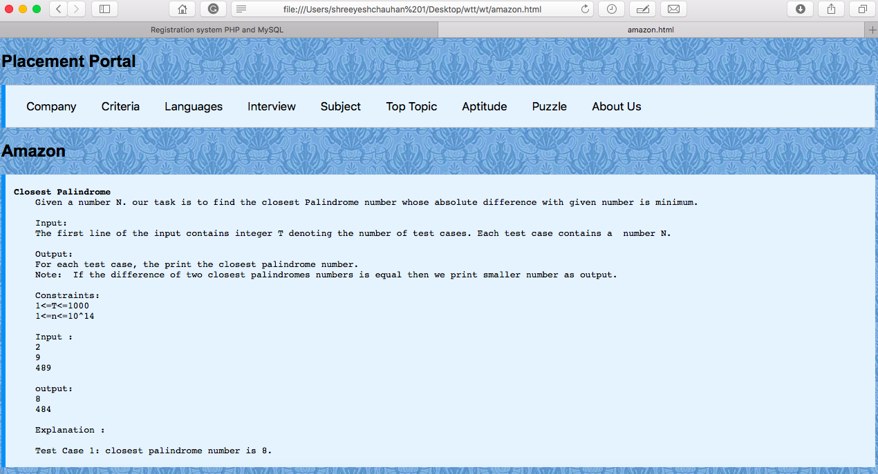

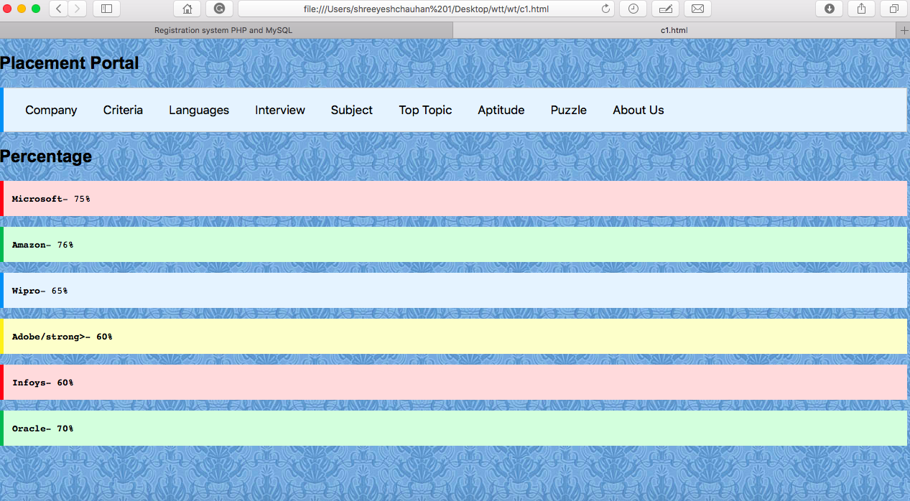

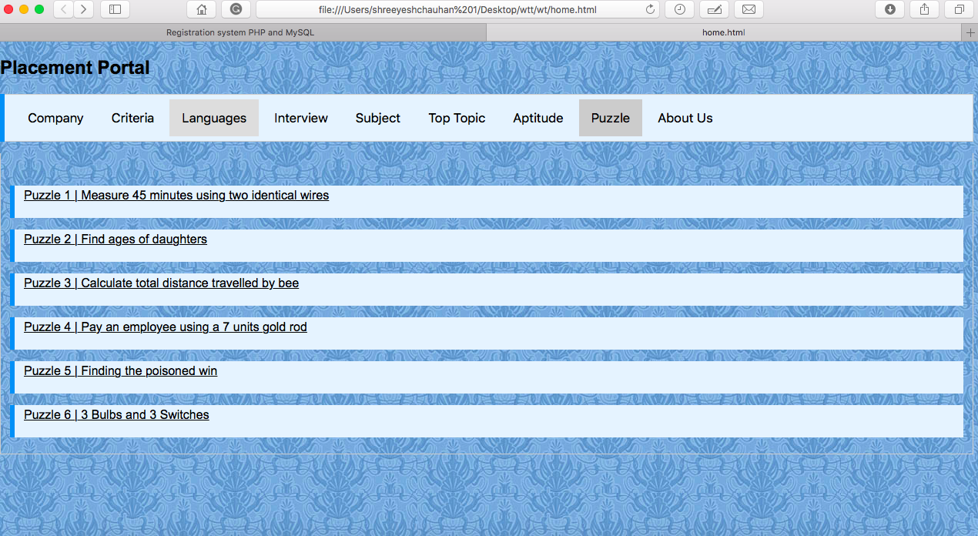

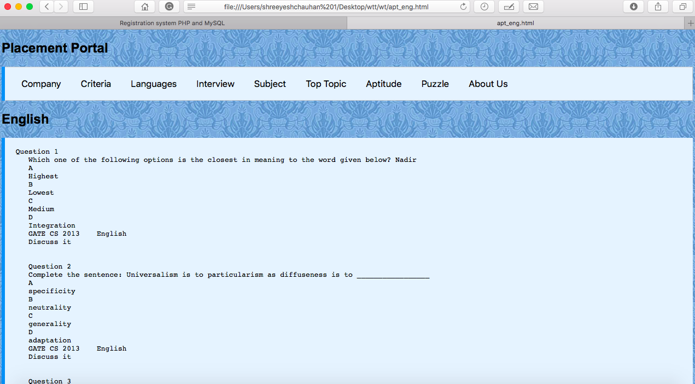

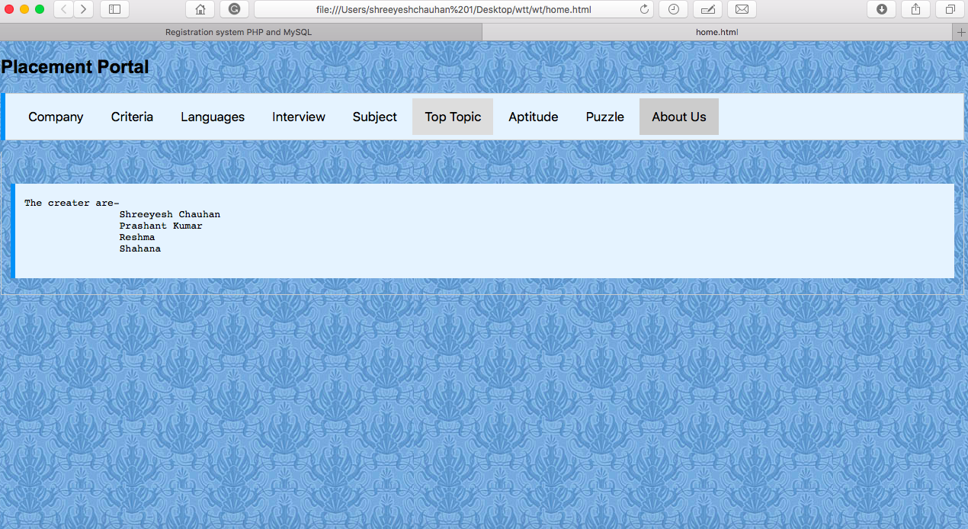

**3.4. Coding:**

<!DOCTYPE html>

<html>

<head>

<meta name="viewport" content="width=device-width, initial-scale=1">

<style>

body {font-family: Arial;

background-image: url("ppp.jpg");

}

/* Style the tab */

.tab {

overflow: hidden;

border: 1px solid #ccc;

background-color: #f1f1f1;

}

/* Style the buttons inside the tab */

.tab button {

background-color: inherit;

float: left;

border: none;

outline: none;

cursor: pointer;

padding: 14px 16px;

transition: 0.3s;

font-size: 17px;

}

/* Change background color of buttons on hover */

.tab button:hover {

background-color: #ddd;

}

/* Create an active/current tablink class */

.tab button.active {

background-color: #ccc;

}

/* Style the tab content */

.tabcontent {

display: none;

padding: 6px 12px;

border: 1px solid #ccc;

border-top: none;

}

.tab{

background-color: #e7f3fe;

border-left: 6px solid #2196F3;

}

.man{

background-color: #ffdddd;

border-left: 6px solid #f44336;

}

.man1 {

background-color: #ddffdd;

border-left: 6px solid #4CAF50;

}

.man2 {

background-color: #e7f3fe;

border-left: 6px solid #2196F3;

}

.man3 {

background-color: #ffffcc;

border-left: 6px solid #ffeb3b;

}

div {

margin-bottom: 15px;

padding: 4px 12px;

}

</style>

</head>

<body>

<h2>Placement Portal</h2>

<div class="tab">

<button class="tablinks" onclick="openCity(event, 'Paris')">Company</button>

<button class="tablinks" onclick="openCity(event, 'criteria')">Criteria</button>

<button class="tablinks" onclick="openCity(event, 'London')">Languages</button>

<button class="tablinks" onclick="openCity(event, 'inter')">Interview</button>

<button class="tablinks" onclick="openCity(event, 'subject')">Subject</button>

<button class="tablinks" onclick="openCity(event, 'top')">Top Topic</button>

<button class="tablinks" onclick="openCity(event, 'apt')">Aptitude</button>

<button class="tablinks" onclick="openCity(event, 'Tokyo')">Puzzle</button>

<button class="tablinks" onclick="openCity(event, 'abt')">About Us</button>

</div>

<div id="London" class="tabcontent">

<br> </br>

<div class="man2">

<a href="c.html"><p>C.</p></a>

</div>

<div class="man2">

<a href="c++.html"><p>C++.</p><a>

</div>

<div class="man2">

<a href="java.html"><p>Java</p><a>

</div>

<div class="man2">

<a href="python.html"><p>Python</p><a>

</div>

</div>

<div id="Paris" class="tabcontent">

<br> </br>

<div class="man2">

<a href="amazon.html"<p>Amazon</p><a>

</div>

<div class="man2">

<a href="microsoft.html"<p>Microsoft</p><a>

</div>

<div class="man2">

<a href="infosys.html"<p>Infosys</p><a>

</div>

<div class="man2">

<a href="wipro.html"<p>Wipro</p><a>

</div>

<div class="man2">

<a href="oracle.html"<p>Oracle</p><a>

</div>

<div class="man2">

<a href="adobe.html"<p>Adobe</p><a>

</div>

</div>

<div id="Tokyo" class="tabcontent">

<br> </br>

<div class="man2">

<a href="p1.html"<p>Puzzle 1 | Measure 45 minutes using two identical wires</p><a>

</div>

<div class="man2">

<a href="p2.html"<p>Puzzle 2 | Find ages of daughters</p> <a>

</div>

<div class="man2">

<a href="p3.html"<p>Puzzle 3 | Calculate total distance travelled by bee</p><a>

</div>

<div class="man2">

<a href="p4.html"<p>Puzzle 4 | Pay an employee using a 7 units gold rod</p><a>

</div>

<div class="man2">

<a href="p5.html"<p>Puzzle 5 | Finding the poisoned win</p><a>

</div>

<div class="man2">

<a href="p6.html"<p>Puzzle 6 | 3 Bulbs and 3 Switches</p><a>

</div>

</div>

<div id="subject" class="tabcontent">

<br> </br>

<div class="man2">

<a href="sub_ds.html"><p>Data Structure.</p></a>

</div>

<div class="man2">

<a href="sub_dbms.html"><p>DBMS.</p><a>

</div>

<div class="man2">

<a href="sub_os.html"><p>OS</p><a>

</div>

<div class="man2">

<a href="sub_net.html"><p>Networking</p><a>

</div>

</div>

<div id="inter" class="tabcontent">

<br> </br>

<div class="man2">

<a href="in1.html"<p>10 Most asked Questions from Java Programmer</p><a>

<body link="#000000" vlink="#000000" alink="#000000">

</div>

<div class="man2">

<a href="in2.html"<p>Commonly Asked C Programming Interview Questions </p> <a>

</div>

<div class="man2">

<a href="in3.html"<p>Commonly Asked OOP Interview Questions</p><a>

</div>

<div class="man2">

<a href="in4.html"<p>Commonly asked DBMS interview questions</p><a>

</div>

</div>

<div id="top" class="tabcontent">

<br> </br>

<div class="man2">

<a href="tt.html"><p>Top 10 algorithms in Interview Questions</p></a>

</div>

<div class="man2">

<a href="tt2.html"><p>Top 20 Dynamic Programming Interview Questions</p><a>

</div>

<div class="man2">

<a href="tt1.html"><p>Top 20 Greedy Algorithms Interview Question</p><a>

</div>

</div>

<div id="apt" class="tabcontent">

<br> </br>

<div class="man2">

<a href="apt_pro.html"><p>Aptitude Probabity</p></a>

</div>

<div class="man2">

<a href="apt_eng.html"><p>Aptitude English </p><a>

</div>

<div class="man2">

<a href="apt_gen.html"><p>Aptitude General</p><a>

</div>

</div>

<div id="abt" class="tabcontent">

<br> </br>

<div class="man2">

<pre>The creater are-

Shreeyesh Chauhan

Prashant Kumar

Reshma

Shahana

</pre>

</div>

</div>

<div id="criteria" class="tabcontent">

<br> </br>

<div class="man2">

<a href="c1.html"><p>Percentage.</p></a>

</div>

<div class="man2">

<a href="c++.html"><p>Skills.</p><a>

</div>

<div class="man2">

<a href="java.html"><p>Communication</p><a>

</div>

<div class="man2">

<a href="python.html"><p>Extra carricular</p><a>

</div>

</div>

<script>

function openCity(evt, cityName) {

var i, tabcontent, tablinks;

tabcontent = document.getElementsByClassName("tabcontent");

for (i = 0; i < tabcontent.length; i++) {

tabcontent[i].style.display = "none";

}

tablinks = document.getElementsByClassName("tablinks");

for (i = 0; i < tablinks.length; i++) {

tablinks[i].className = tablinks[i].className.replace(" active", "");

}

document.getElementById(cityName).style.display = "block";

evt.currentTarget.className += " active";

}

</script>

</body>

</html>

Webpage:

<!DOCTYPE html>

<html>

<head>

<meta name="viewport" content="width=device-width, initial-scale=1">

<style>

body {font-family: Arial;

background-image: url("ppp.jpg");

}

/* Style the tab */

.tab {

overflow: hidden;

border: 1px solid #ccc;

background-color: #f1f1f1;

}

/* Style the buttons inside the tab */

.tab button {

background-color: inherit;

float: left;

border: none;

outline: none;

cursor: pointer;

padding: 14px 16px;

transition: 0.3s;

font-size: 17px;

}

/* Change background color of buttons on hover */

.tab button:hover {

background-color: #ddd;

}

/* Create an active/current tablink class */

.tab button.active {

background-color: #ccc;

}

/* Style the tab content */

.tabcontent {

display: none;

padding: 6px 12px;

border: 1px solid #ccc;

border-top: none;

}

.tab{

background-color: #e7f3fe;

border-left: 6px solid #2196F3;

}

div {

margin-bottom: 15px;

padding: 4px 12px;

}

.red {

background-color: #ffdddd;

border-left: 6px solid #f44336;

}

</style>

</head>

<body>

<h2>Placement Portal</h2>

<div class="tab">

<button class="tablinks" onclick="openCity(event, 'Paris')">Company</button>

<button class="tablinks" onclick="openCity(event, 'criteria')">Criteria</button>

<button class="tablinks" onclick="openCity(event, 'London')">Languages</button>

<button class="tablinks" onclick="openCity(event, 'inter')">Interview</button>

<button class="tablinks" onclick="openCity(event, 'subject')">Subject</button>

<button class="tablinks" onclick="openCity(event, 'top')">Top Topic</button>

<button class="tablinks" onclick="openCity(event, 'apt')">Aptitude</button>

<button class="tablinks" onclick="openCity(event, 'Tokyo')">Puzzle</button>

<button class="tablinks" onclick="openCity(event, 'abt')">About Us</button>

</div>

<h2>10 Most asked Questions from Java Programmer</h2>

<div class="red">

<pre><strong></strong> Hope you liked my previous post “Top 25 Interview Questions”. Here comes the next 10.

1) Design discussion on elevator.

Hint: Ask questions related to elevator functionality; come up with a High Level design and Low level design. Be prepared for scheduling questions related to elevator.

2) “n” points are given , find the number of quadruplets which form square.

3) Questions related to memory management in Java.

4) Mark and sweep algorithm and garbage collection in Java

5) Construct tree from Inorder and Preorder

6) Serialization in Java

7) How to ensure that instance is never garbage collected?

Hint: We can use singleton pattern. There’s a static reference to a singleton, so it won’t be eligible for garbage collection until the classloader is eligible for garbage collection.

8) Questions related to classloader, rt.jar?

9) Difference between String, StringBuffer and StringBuilder?

10) Why String is immutable in Java?</pre>

</div>

</body>

</html>

**4.FUTURE SCOPE**

In proposed Advanced training and placement system there is big scope for improvement of the system. We can extend this system for city wise colleges.so that we have to maintain only one web portal for city. For the pool campus conducted in our college, we can give limited access to the system to other college students also. Apart from these there is scope for generating many features. The Online aptitude test can be integrated with the online placement system so the student can give the test from anywhere. There can be many more future Enhancement & improvement in the Online Placement System.

**5.CONCLUSION**

In the existing Placement system, there was poor communication and opportunities for alumni student. Also current students were not get any guidance from senior students.

Proposed system gets automated. This system provides registration all the user, activation and deactivation of the user, personalization to the user, resources to be provided online, communication between the users, online feedback. Students can update their own data. The admin can see the user’s information and will validate it accordingly, generate the student list based on the company criteria, company details can be provided to the user, searching and sorting of users can be done, and reports can be generated. Admin will notify each student by sending mail. Alumni data can be maintained. Overall the process of the placement department is automated and advanced.

**6. REFERENCES**

1. **www.w3schools .com**
2. [**www.github.com**](http://www.github.com)
3. [**www.youtube.com**](http://www.youtube.com)